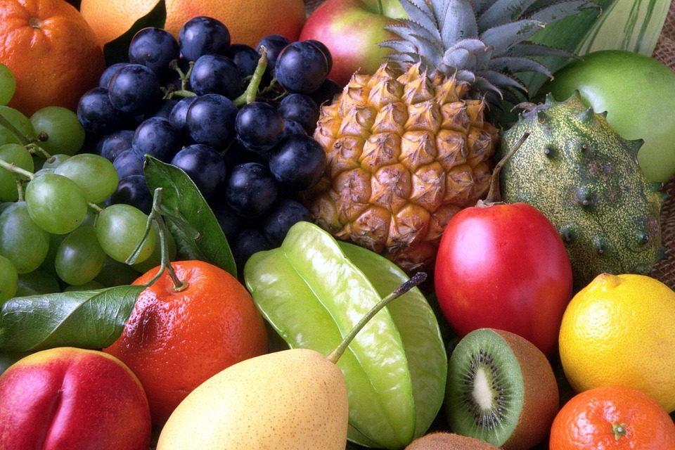
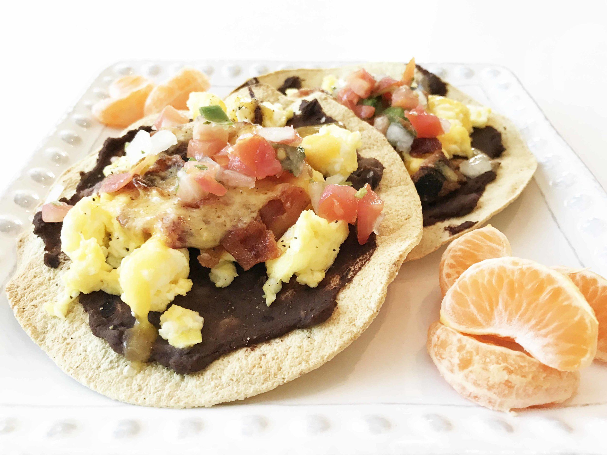
Healthy Bodies – Healthy Minds
MENU
May12-May16, 2025
A rainbow of colorful nutritious food helps us grow strong and healthy!

 | Monday 12 | Tuesday 13 | Wednesday 14 | Thursday 15 | Friday 16
Breakfast | Kix Cereal(wgr): ¼ cup  Apples: ½ cup  Milk: ¾ cup | Cream of Wheat: ¼ cup  Orange: ½ cup  Milk: ¾ cup | Corn Flakes: ½ cup  Pears: ½ cup  Milk: ¾ cup | Life Cereal (wgr): ½ cup  Watermelon: ½ cup  Milk: ¾ cup | W.W. Eng. Muffin(wgr): ½ ea.  Banana: ½ cup  Milk: ¾ cup
Lunch | Tofu Noodle Soup  Tofu:3/8cup  Egg Noodle: ¼ cup  Baby cut Carrots: ¼ cup  Pears: ¼ cup  Milk: ¾ cup | Coconut Curry Chickpea  Chickpea(w/sauce):1cup  Brown Rice(wgr): ¼ cup  Cauliflower: ¼ cup  Cantaloupe: ¼ cup  Milk: ¾ cup | Cheese Sandwich  W.W. Bread(wgr):1slice  Sliced Cheese:1 ½ oz  Bell Pepper Strips: ¼ cup  Banana: ¼ cup  Milk: ¾ cup | Bean Tostadas  Pinto Bean: 1/8 cup  Mix Cheese:1 oz.  Corn Tortilla: 1ea  Sliced Tomatoes: ¼ cup  Oranges: ¼ cup  Milk: ¾ cup | Turkey Burger  Ground Turkey:1 ½ oz.  Mini slider buns:1each  Coleslaw: ¼ cup  Pears: ¼ cup  Milk: ¾ cup
Snack | Yogurt: ¼ cup  Pineapple: ½ cup | Fresh Vegetable: ½ cup  Veggie Dip:1tbsp  W.W. Crackers(wgr): ½ oz | Fruit Compote Muffin:1each  Milk: ½ cup | Raisin Bread: ½ slice  Sliced Apples: ½ cup | Trial Mix: ½ cup  (mix Cereal-Crackers-Dry fruit)  Fruit Medley: ½ cup

§Alternative items for milk/ dairy (w/ med. documentation): Soy milk •Alternative items for meat: Beans, tofu, &/or cheese
*Alternative items for gluten & soy will be served with medical authorization only. W.W. = Whole Wheat

Milk: Whole milk is served to children aged 12 mos. to 23 mos. (wgr) = Whole Grain
Low Fat (1% fat) milk is served to children 2 years old through school-age.

“Fruit Medley” = Any fresh fruit available at the site.

