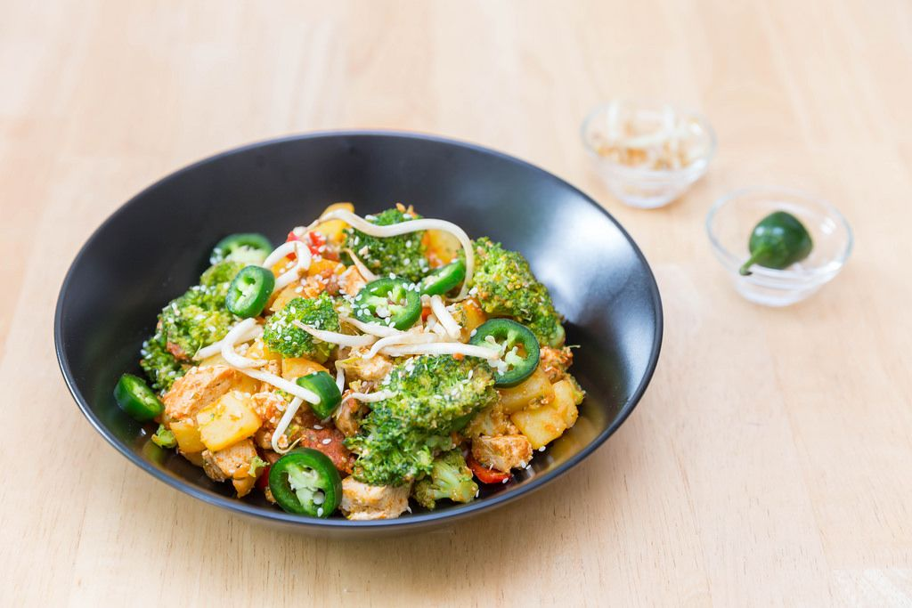
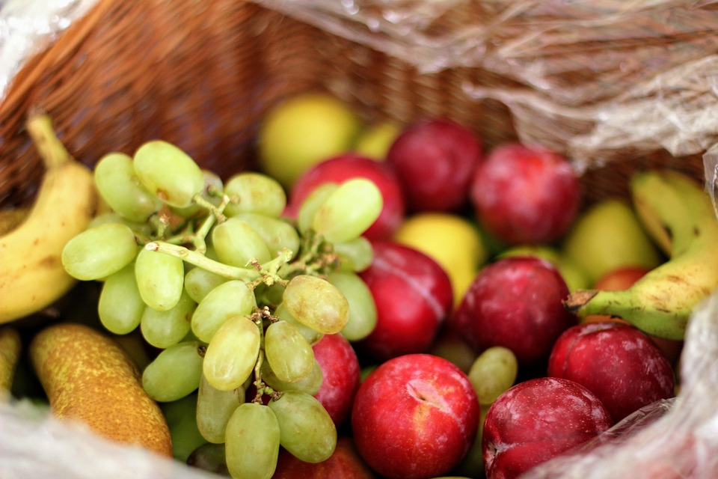

Healthy Bodies –Healthy Minds
MENU
May 05-May 09, 2025
A rainbow of colorful nutritious food helps us grow strong and healthy!

 | Monday 05 | Tuesday 06 | Wednesday 07 | Thursday 08 | Friday 09
Breakfast | Oatmeal(wgr): ¼ cup  Oranges: ½ cup  Milk: ¾ cup | Kix Cereal (wgr): ½ ea.  Pears: ½ cup  Milk: ¾ cup | Life Cereal(wgr): ½ cup  Apples: ½ cup  Milk: ¾ cup | W.W. Eng. Muffin (wgr): ½ each  Honeydew: ½ cup  Milk: ¾ cup | Cheerios(wgr): ½ Cup  Banana: ½ cup  Milk: ¾ cup
Lunch | Lentil Sweet Potato Stew  Lentil Sweet Potato Stew:1cup  Mini Naan Bread:1each  Swiss Chard: ¼ cup  Apples: ¼ cup  Milk: ¾ cup | Pasta Marinara  Noodle(W/sauce): ¼ cup.  Mix Vegetable: ¼ cup.  Edamame: 3/8 cup  Banana: ¼ cup  Milk: ¾ cup | Vegetarian Pea Soup  Vegetarian Pea Soup:1cup  Sliced Green Bell Pepper: ½ cup  W.W. Cracker(wgr): ½ oz  Oranges: ¼ cup  Milk: ¾ cup | Kung Pao Chicken  Baked Chicken (w /sauce):1 ½ oz  Brown Rice(wgr): ¼ cup  Green Bean: ¼ cup  Strawberries: ¼ cup  Milk: ¾ cup | Turkey Sandwich  Sliced Turkey:1 ½ oz  W.W. Bread(wgr):1slice  Baby Cut Carrots: ¼ cup  Cantaloupe: ¼ cup  Milk: ¾ cup
Snack | W.W. Pita. Bread: ½ slice  Hummus:1/8cup | Cottage Cheese: ¼ cup  Pineapple: ½ cup | Birthday Muffin:1each  Milk: ½ cup | Sliced Cheese:1oz  Fruit Medley: ½ cup

§Alternative items for milk/ dairy (w/ med. documentation): Soy milk •Alternative items for meat: Beans, tofu, &/or cheese
*Alternative items for gluten & soy will be served with medical authorization only. W.W. = Whole Wheat

Milk: Whole milk is served to children aged 12 mos. to 23 mos. (wgr) = Whole Grain
Low Fat (1% fat) milk is served to children 2 years old through school-age.

“Fruit Medley” = Any fresh fruit available at the site.

