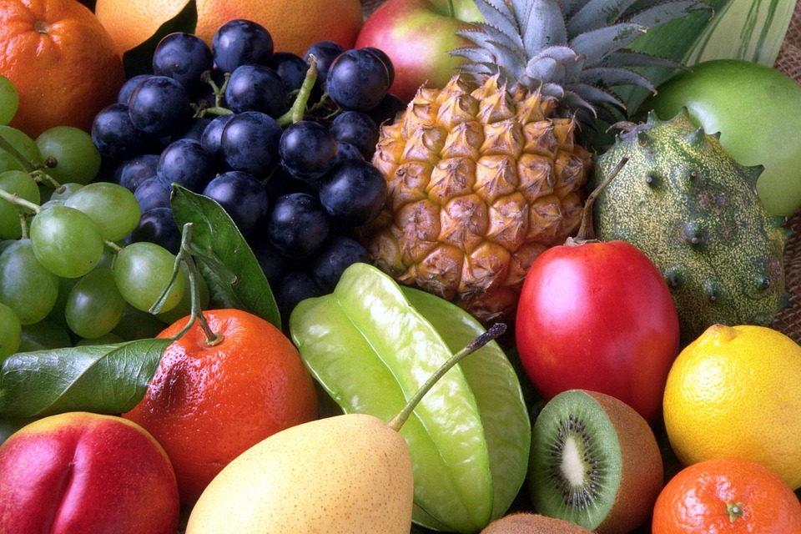
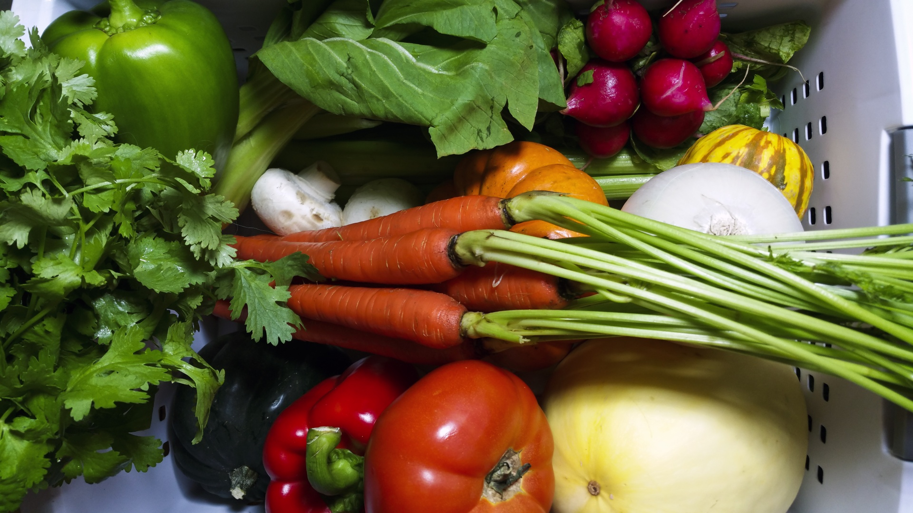
Healthy Bodies – Healthy Minds
MENU
May 19-May 23, 2025
A rainbow of colorful nutritious food helps us grow strong and healthy!

 | Monday 19 | Tuesday 20 | Wednesday 21 | Thursday 22 | Friday 23
Breakfast | Kix Cereal(wgr): ½ cup  Pears: ½ Cup  Milk: ¾ cup | Life Cereal(wgr): ½ cup  Honeydew: ½ cup  Milk: ¾ cup | Rice Pocket: ¼ cup  Apples: ½ cup  Milk: ¾ cup | Mini Wheats(wgr): ½ cup  Honeydew: ½ cup  Milk: ¾ cup |  | Cream of Wheat: ¼ cup  Banana: ½ cup  Milk: ¾ cup
Lunch | Turkey Ginger Rice Soup  Turkey Ginger Rice Soup:1cup  W.W. Crackers (wgr): ½ oz.  Baby Cut Carrots: ¼ cup  Oranges: ¼ cup  Milk: ¾ cup | Tofu Noodle Stir-Fry  Tofu(w/sauce):3/8 cup  Egg Noodle: ¼ cup  Baby Bok Choy: ¼ cup  Banana: ¼ cup  Milk: ¾ cup | Mini Bagel-Cream cheese  Mini Bagle:1each  Cream Cheese:1tbsp  Edamame: ¾ cup  Sliced Cucumber: ¼ cup  Cantaloupe: ¼ cup  Milk: ¾ cup | Black Beans Pumpkin Chill  Black Beans:3/8 cup  Brown Rice(wgr): ¼ cup  Collard Green: ¼ cup  Pineapple: ¼ cup  Milk: ¾ cup |  | Tomato basil Baked Cod Fish  Baked Cod(w/sauce): 1 ½ oz  Corn Bread:1each  Cole Slaw: ¼ cup  Strawberries: ¼ cup  Milk: ¾ cup
Snack | Raisin Bread: ½ slice  Applesauce: ½ cup | Sliced Cheese:1oz  W.W. Cracker(wgr): ½ oz |  | Pita Chip: ½ oz  Hummus:1/8cup |  | Cottage Cheese: ¼ cup.  Fruit Medley: ½ cup

§Alternative items for milk/ dairy (w/ med. documentation): Soy milk •Alternative items for meat: Beans, tofu, &/or cheese
*Alternative items for gluten & soy will be served with medical authorization only. W.W. = Whole Wheat

Milk: Whole milk is served to children aged 12 mos. to 23 mos. (wgr) = Whole Grain
Low Fat (1% fat) milk is served to children 2 years old through school-age.

“Fruit Medley” = Any fresh fruit available at the site.

